Project proposal

A minimal viable product set of laboratory experiments

Submitted by:

1. Mostafa Eliwa
2. Ahmed AlGhannam
3. Ahmed Nashaat

Supporting Faculty:

Dr. Mostafa Abdalla

# Introduction

In this stage Zlabs team has finished building the first prototype example (The position control experiment) funded by ZC. The prototype cost about 5000 LE in total.

Our next step is to produce three experiments of a minimal viable product that is market ready.

The goal is to produce the three experiments with High quality and global standards. This is a proposal for initial fund from ZC to kick start the cycle of producing the experiments.

# Experiments description:

## First product: Position control

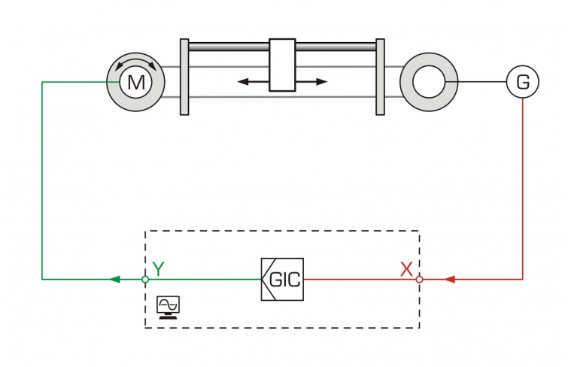

**Figure 1: position control experiment schematic.**

Control lab that serves more than 3 departments in the university (Communication, Aerospace, and Renewable engineering and other) we aim to lay the cornerstone in the control lab by designing and producing the position control. Position control is a machine that enables students to understand the basic control concepts and the variables that affect the performance of controlling the machine. The setup points out and demonstrates the control theory for students to learn the fundamentals of control engineering through experimentation on a linear position control system.

## Second product: Hydraulic Bench

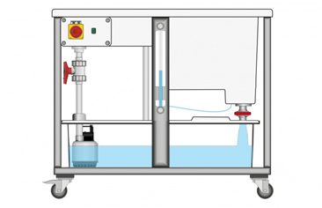

**Figure 2: Hydraulic Bench schematic**

As part of any fluid mechanics lab, the hydraulic bench is the key piece of equipment for any experiment. The design of the hydraulic bench affects the whole lab and must be optimized in all aspects. This is the reason why we aim to give it a head start in time for designing and optimizing it before we start the final design in Zlabs.

The hydraulic bench has been designed to provide continuous and controlled supply of water to conduct various experiments using auxiliary modules in typical Fluid Mechanics and Hydraulics Laboratory. It is a mobile self-contained bench to provide a variable supply of water to a series of interchangeable bench mounting or floor-standing hydraulic and fluid mechanics experiments.

## Third product: thermal wind tunnel

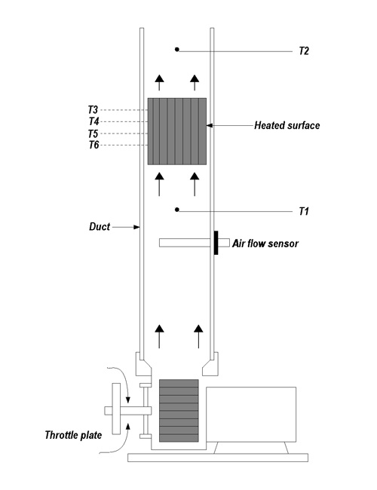

**Figure 3: thermal wind tunnel schematic**

As part of renewable and aerospace study the thermal/fluid mechanics interaction is a very sophisticated area. The thermal wind tunnel is a device that allows the student to visualize and measure the effect of fluid mechanics on hot, cold objects. Also it allows students to change the variables that governs the interaction between the fluid and thermodynamics.  
The device requires calibration, testing, and development so we aimed to select this product as a target complexity. If we made it through this device we will be able to work on almost all products needed in the market in the future.

In this setup, we will examine three kinds of tests with a wide range of experiments that can be conducted at different conditions. The tests induces:

1. Flat plate convection (free-forced)

2. Pinned surface (free-forced)

3. Finned surface (free-forced)

Each test has the option to change the velocity that passes the surface and change the power dissipated by this surface. Thermocouple are along the duct at three different places. Before the surface, at the surface, and after the surface. A speed sensor is mounted to measure the speed of the airflow.

# Supply chain

• Contact the suppliers to make a database with the contacts and prices

Our suppliers divided into local and foreign ones. At this stage we can get an estimation of the components in the market and the quality versus price. Also, we can build our database containing all prices and the quality degree for each.

• Estimate the needed time to receive the requested components

Estimating the time is a critical point in the plan. After dividing the components into local and foreign we should get a rough estimation of the needed time for each of them to reach us safely.

# Manufacturing strategy:

We aim to produce high quality products that needs continuous development on our tools and machines. Our ability to manufacture any device will be governed by a learning curve that expected to be 100% of the quality required after 3-5 years.

We will continuously document our failures and success trials in order to keep track of our quality.

**Attached a Gantt chart shows the production plan of the 3 products mentioned above.**

# Budget

The expected total budget is estimated to be 100,000 LE in maximum